**Knox Makers Holiday Star V1 Kit Instructions**

December 2019

We usually assemble circuit boards starting with the lowest profile components and work our way up to the taller, higher profile components. This board has components on both the front and the back; for ease of assembly we will solder the front components first, the back ones last.

**Start with the resistors**

With this circuit board, like most, we’ll start with the resistors. Resistors are usually labeled on schematics and circuit boards as R1, R2, R3, etc. Resistors are not polarized components so they can be inserted with either end in either hole. They are typically labeled with colored rings. This kit can be built with a wide range of resistor values so use whatever was included in the kit. All of the resistors are of the same value so any resistor can go into any position on the circuit board.

For each resistor bend its leads 90 degrees, insert the resistor from the front and bend the leads outward on the back around 45 degrees to hold it in place. Resistors should sit fairly flush with the circuit board and hold in place when the circuit board is upside down.

You might find it helpful to go ahead and solder the resistors in place and trim the leads on the back flush so they aren’t in the way of the next components.

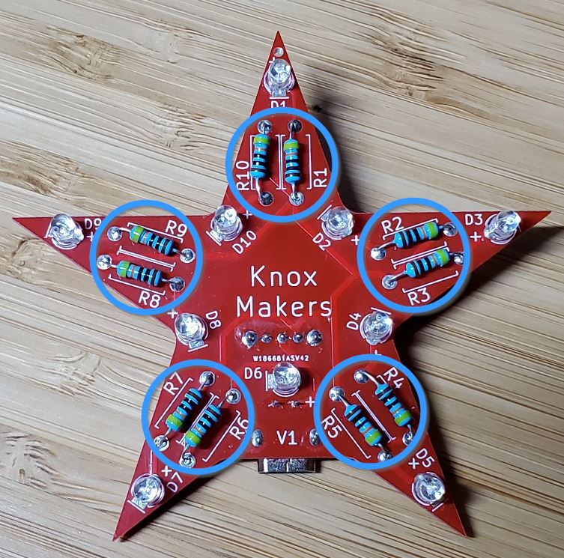

**Now the LEDs**

LEDs are a type of diode and all diodes are polarized with one lead being the anode and one being the cathode. There are two ways to identify which lead is which on an LED. The shorter leg is the cathode, the longer leg the anode. There is also a flat side on the LED housing which indicates that side is the cathode.

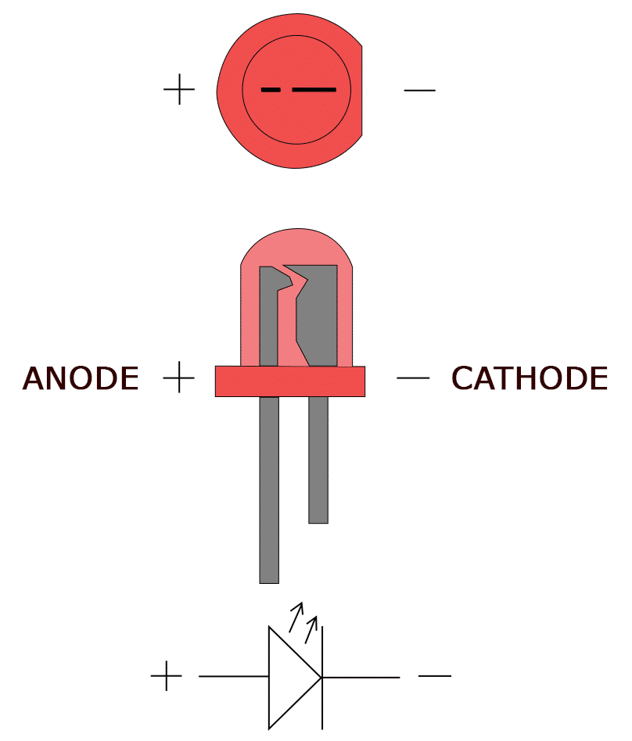

The circuit board has two visual indicators – the “+” signifies the anode lead and the line indicates the flat on the diode, or the cathode, as shown below

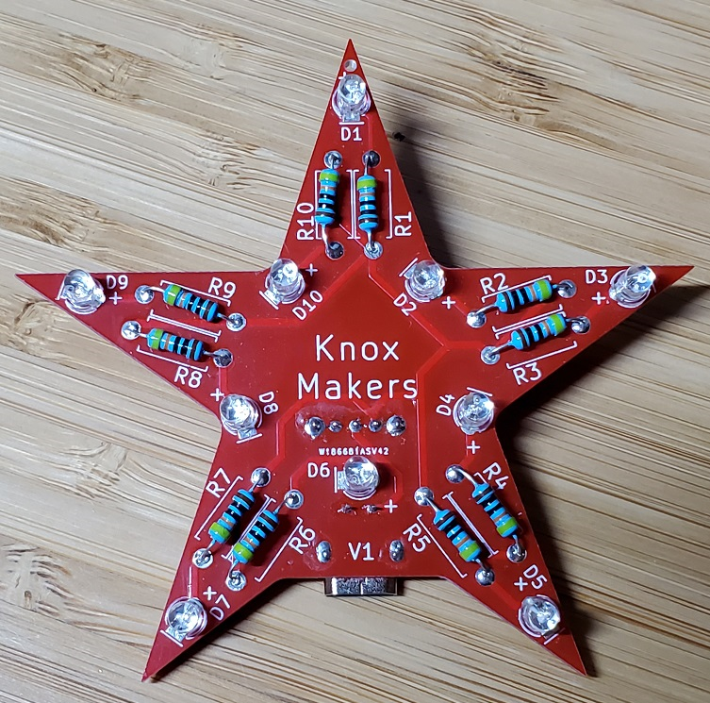

Insert the diodes, carefully noting lead polarity, bend the leads outward on the back, solder them and trim the leads flush.

**The USB Power Jack**

Bend the two leads on the USB power jack at a right angle as shown:

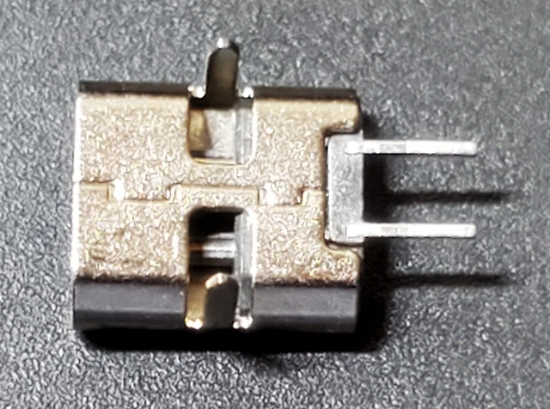 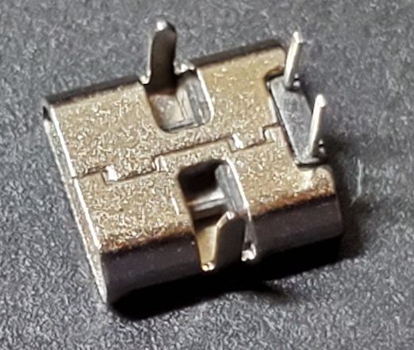

Now insert it into the back of the board, flip the board over and solder it in place being careful to keep the power jack flush on the back. The power jack has plastic molding inside so try to work quickly as you solder to avoid melting the plastic.

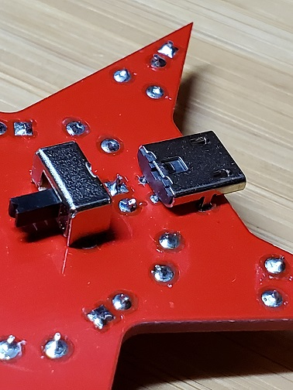

**Finally, the power switch**

Insert the power switch into the back as shown in the last picture and solder it from the front, similar to the power jack. Again work quickly to avoid melting the plastic.

**Test and debug**

Plug a USB micro cable into the power jack, flip the switch and you should see the LEDs light up and begin to blink.

If nothing is working then check that the USB power jack is inserted from the back and each of the 4 connections is soldered properly. Make the same check for the power switch. If these two things check out then it may be that all of the diodes were soldered in backwards. Try to unsolder one, reverse it and see if it lights up, indicating polarity was backwards.

If one or two LEDs aren’t lighting up then they are probably soldered in backwards or possibly there’s a bad LED.

Congratulations, you did it!

**Theory of Operation**

The circuit is simply a power source, a switch and 10 diodes with resistors. The USB jack provides a 5V power source to the circuit. The switch simply disconnects power from the rest of the circuit when it’s in the off position. The LEDs contain internal circuitry that causes them to flash. Each LED has a resistor in series with it to limit the current through the device.

**Bill of Materials**

|  |  |  |
| --- | --- | --- |
| **Qty** | **Designator** | **Item** |
| 1 | - | PCB |
| 1 | J1 | USB Micro Power Jack |
| 1 | S1 | Slide Switch |
| 10 | R1-R10 | Resistors |
| 10 | D1-D10 | 3mm flashing LEDs |



